CONFINED SPACE ENTRY PROGRAM OVERVIEW
This confined space entry program:
- Identifies all permit-required confined spaces in our workplace; and
- Describes our procedures for worker safety and health in permit-required confined spaces
- Complies with WAC 296-809
There are three roles during this process, and they are:
The first, and the one at highest risk, is the entrant. Before going in, the entrant needs to have direct authorization from their employer to enter the space. The DOSH Confined Space standard states that the entrant must:
- Know the hazards associated with confined space entry, and in particular, the hazards associated with the PRCS being entered.
- Know how to use all required equipment.
- Know the procedures for communication with the attendant.
- Know how to alert the attendant of hazardous or prohibited conditions.
- Know how to exit the space if necessary (that is, self-rescue).
The second party of the confined space team is the attendant. There must be at least one attendant on each PRCS team. The attendant arguably has the most amount of responsibility on the confined space team, as they have the highest number of duties required by OSHA. These duties are to:
- Know the hazards. In the case of the attendant, this can often include using air monitoring equipment to keep a close watch on the atmospheric conditions inside the confined space and communicate any changes observed.
- Know the behavioral effects of the hazards.
- Be able to identify the authorized entrants.
- Remain outside until relieved.
- Communicate with entrants throughout the work period.
- Monitor and evacuate entrants if necessary.
- Summon rescue, if needed.
- Warn away unauthorized persons.
The third and last required party on a PRCS team is the entry supervisor. In most cases, the entry supervisor is the employer or directly represents the employer. It is a good idea for this person to be trained and ready to serve as an entrant or attendant, if need be, as well. The entry supervisor is responsible for determining whether acceptable entry conditions exist, authorizing the entry, overseeing entry operations, terminating the entry, and canceling the entry permit. Per the regulation, the entry supervisor must:
- Know the hazards.
- Verify safe entry conditions.
- Terminate entry and cancel permit.
- Verify availability and effectiveness of rescue services.
- Remove unauthorized persons.
- Ensure acceptable entry conditions are maintained.
Employees will participate in developing and implementing the program in the following ways:
______________________________________________________________________________
______________________________________________________________________________
______________________________________________________________________________
<<COMPANYNAME>> will treat all confined spaces as permit-required spaces. All entries will require either a permit or alternative methods documentation.

Roles and Responsibilities
We have designated <<COMPANYHR> as a Confined Space Program Administrator with overall responsibilities for this program.

Table 1 Confined Space Program Assignment and Responsibilities
Responsibility: | Person assigned this responsibility:
Evaluate our work locations and determine:
- Determine confined space(s) exist at the worksite.
- Identify Permit-required confined space(s) at the worksite. For example: Name of the Competent Person or Entry Supervisor
Record information in the confined space catalog. See Table 2 for more information.
Evaluate hazards and determine the appropriate entry procedure(s) for the space.
Note:
- Classify all confined spaces as permit required until you meet all the requirements of the 600 section Alternative methods.
- Alternative methods only apply after the elimination of the physical hazards, and monitoring data of the space demonstrates only hazard remaining in the space is a potential hazardous atmosphere controlled by the use of forced air ventilation. Atmospheric monitoring required.
Create employee training program that results in the necessary knowledge, skills and abilities for all the active participants to implement your confined space entry program including training on your program, entry procedures.
Determine employee proficiency in knowledge, skills and abilities.
Implement the corresponding confined space entry procedures
Re-evaluate the space when the use, configuration, or hazards of a confined space change.
Monitoring and testing by:
- Conducting initial monitoring to identify and evaluate any potentially hazardous atmospheres.
- Complete atmospheric testing in the following order:
  - Oxygen
  - Combustible gases
  - Toxic gases and vapors
- Location of the instrument manual and operating procedures (specify location)
- Record the data (specify location)
- Record instrument calibration and functional tests (Specify location)
Keep these records on-site in (Specify location)
Inform exposed or potentially exposed employees of the existence and hazards of confined spaces using the methods described below under “Control Confined Space Entry.” Post permit required warning signs.
Provide employees entering confined spaces, or their designated representative, an opportunity to observe pre-entry testing and any subsequent testing.
- All test results will be provided to the entrants or their representatives upon request.
- The space will be re-evaluated if entrants or their representatives believe that the permit space was inadequately tested.
Make sure that all equipment needed for safe entry into any confined space is available and in proper working order.
Confined Space Program Administrator conducts a review using the canceled entry permits to identify and correct any deficiencies in our program.

Identify Confined Spaces and Hazards
The following table provides a list of our confined spaces and hazards:

Table 2 Catalog of Confined Spaces and Hazards
Confined Space (name or number) | Type of space (tank, hopper, sump, pit etc.) Plus configuration (length x width x depth or height) | Access (hatch, ladder, crawling, through a pipe chase etc.) Access dimensions | Location | Hazards include potential and actual including hazards created from the process | Entry procedures Available Y/N

Control of Confined Space Entry
We use the following method(s) to inform employees about the existence and hazards of confined spaces, and prevent unauthorized entry:
- Posting danger signs at each permit space reading “Danger-Confined Space - Do Not Enter”. Additional means used to prevent entry (lock access point open, etc.):
______________________________________________________________________________
______________________________________________________________________________
______________________________________________________________________________

Permit Entry Procedures
Our entry procedures for permit spaces include the following:
(Either insert your safe work practices and procedures here. OR provide references to the actual location of the procedures you expect your employees to use.) ______________________________________________________________________________
______________________________________________________________________________
______________________________________________________________________________
This checklist will help in the review of the procedures you may use to enter and complete work include the following:
- Procedure 01 Energy Control Lockout (LOTO) program and procedures
- Procedure 02 Atmospheric monitoring including instrument calibration, functional testing (calibration or “bump” check)
- Procedure 03 Job Hazard Analysis (Hazard identification)
- Procedure 04 Hazard identification
- Procedure 05 Ventilation
- Procedure 06 Inerting Process
- Procedure 07 Equipment related procedures like testing, calibration, maintenance use for all the equipment
- Procedure 08 Rescue Procedure(s) non-entry and entry rescue
- Procedure 09 Closing a permit required confined space(s) and canceling the permit
- Procedure 10 Coordinating with an outside employer
- Procedure 11 Communication procedures including emergency communications
- Procedure 12 Specific hazard elimination procedures

Alternate Methods and Hazard Elimination Procedures
Our hazard elimination procedures for permit spaces include the following:
(Either insert your safe work practices and procedures here. OR supply references to the actual location of the procedures you expect your employees to use.)
______________________________________________________________________________
______________________________________________________________________________
______________________________________________________________________________
Our permit spaces that have had all hazards eliminated or all physical hazards and the only hazard that remains an actual or potential hazardous atmosphere may use alternative methods. While using alternative methods require the use of documentation to communicate the required information to the entrant. WAC 296-809-600 Alternative methods for additional information.
Alternate method procedures may be used for the spaces listed in the following table when the hazard elimination procedures located (Customize with location of Hazard Elimination Procedures) have been implemented by the confined space supervisor prior to entry, and we have completed the required documentation for the entrant.
Confined Space (name or number) | Hazards include potential and actual including hazards from the process | Method of Hazard Elimination | Potential Hazardous Atmosphere | Ventilation equipment required

We will do all the following when using alternate methods procedures:
- Eliminate unsafe conditions and hazards by implementing our alternative methods procedures:
  - Including removing entrance covers safely, promptly guard the opening with a railing, temporary cover, or other temporary barrier to prevent accidental falls through the opening and protect entrants from objects falling into the space, using hazard elimination procedures.
  - Certify that pre-entry measures and implementing hazard elimination procedures on the documentation required for entry.
  - Make the pre-entry certification available to each entrant before entry.
- Before an employee enters the confined space, check the calibration date on the instrument to ensure that calibration is within the manufacture’s specification; complete a calibration check or functional test with a known traceable gas test mixture; record the results in the log, ensure you have the correct gas sensors in the instrument for the hazardous atmospheric testing. Follow the confined space sampling procedure (insert number or location here). Allow the instrument sufficient time to respond at each sampling location. Record the results of the atmospheric tests on the documentation. Test the internal atmosphere with a calibrated, direct-reading instrument for all the following, in this order:
  - Oxygen content
  - Flammable gases and vapors
  - Potential toxic air contaminants.
- Provide entrants, or their authorized representatives, with an opportunity to observe the pre-entry and periodic testing.
  - Make sure the atmosphere within the space is not hazardous when entrants are present.
- Use continuous forced air ventilation, as follows:
  - Wait until the forced air ventilation has removed any hazardous atmosphere before allowing entrants into the space and verify with another air test.
  - Direct forced air ventilation toward the immediate areas where employees are, or will be, and continue ventilation until all employees have left the space.
  - When using this process, exhaust ventilation will also be incorporated in the task.
  - Provide the air supply from a clean source and make sure it does not increase hazards in the space.
- Test the atmosphere within the space as needed to make sure hazards do not accumulate.
- If a hazardous atmosphere is detected during entry, we will do all of the following:
  - Evacuate employees from the space immediately.
  - Evaluate the space to determine how the hazardous atmosphere developed.
  - Implement measures to protect employees from the hazardous atmosphere before continuing the entry operation.
  - Verify the space is safe for entry before continuing the entry operation.
- The written documentation is available to each employee entering the space or to that employee’s representative at the confined space bulletin board.

Alternative Methods Documentation Form
Location of the Space
Entry Date: |  |  | Entry Duration:
List of Entrants:
List of Physical Hazards in the space |  |  | List of (Potential or Actual) Atmospheric Hazards in the space
List each action taken to eliminate physical and atmospheric hazards in the space
Action |  |  | Description
Ventilation
Is forced air ventilation required? |  |  | YES | NO
If “Yes” specify type of ventilation like local exhaust?  Are multiple units required? |  |  | Amount of ventilation (cfm or AC/hr.)
Air Monitoring
Substance Monitored | Unit | Permissible Levels |  | Monitoring Results
 |  |  |  | Initial  Test | Peak  Reading  during  entry
Instruments used for Air Monitoring
Model number or type |  |  | Calibration  Date: | Calibration Check Date:
Additional notes about the space and entry (including whether evacuation was necessary)
Person Responsible for Ensuring the Space is Safe to Enter
Name: |  |  | Job Title:
Signature:

Training
We will provide permit space training to employees at the following times:
- When hired, so new employees are aware of our confined spaces
- Before they are assigned permit space entry duties
- When their assigned duties change; and
- When there is a change in a space that creates hazards for which they have not been trained
- Retraining for employees when you have any reason to believe they are not proficient at their confined pace duties including procedural changes or not following existing procedures.

Following are 6 basic categories of training, based on duties and potential exposure:
- Awareness training provided to all employees potentially exposed to permit spaces, covering the following:
  - The location and hazard of each space
  - The company program for confined spaces
  - Emphasis on not entering the space for any reason
- Identification of permit required confined spaces:
  - Competent person
  - Entry supervisors
- Program administrator.
- Entry and exit training for the following team members:
  - Entrants
  - Attendants
  - Entry Supervisors
  - Rescue team members
  - Competent Person
  - Confined Space Program Administrator
- Training on how to manage confined space entries for entry supervisors.
- Rescue – rescue procedures, equipment, inspections, set up, and use:
  - Non-entry rescue including - attendants
  - Entry rescue team members
- Pre-entry program and procedure training for all:
  - Entrants
  - Supervisors
  - Attendants
  - Rescue team members
- Training on evaluating and testing confined spaces for:
  - Entry supervisors
  - Staff assigned to test and evaluate the space
- Retraining for employees when you have any reason to believe they are not proficient at their confined space duties.

OUR RESPONSIBILITIES FOR CONTRACTORS
A copy of this Confined Space Entry Program will be provided to each contractor involved in permit space entry work at our company. Each contractor will be briefed on the following:
- The location of the permit spaces at our insert location here
- Entry into permit spaces is only allowed by following the written entry program.
- The reasons for listing the space as a permit space, including both of the following:
  - The identified hazards
  - Our experience with the particular space.
- Precautions we have implemented to protect employees working in or near the space.
- Who will debrief the contractor at the completion of entry operations, or during entry if needed, on whether any hazards were confronted or created during their work.

Rescue and Emergency Services
We have developed the following rescue and emergency action plan:
______________________________________________________________________________
______________________________________________________________________________
______________________________________________________________________________
ENTRY RESCUE PLANS

Permit Spaces Requiring Stand-by Rescue Services
Note: You must complete the evaluation of the rescue and emergency service and have an agreement in place.
Permit space: | Stand-by rescue service name and direct telephone number:
(911 is not considered a rescue service. Contacts and direct numbers are needed)

PERMIT-REQUIRED CONFINED SPACE PROGRAM REVIEW
At least every 12 months we will conduct a review using canceled entry permits to identify any deficiencies in our program. We will conduct a review immediately if there is reason to believe that the program does not adequately protect our employees, such as the following situations:
- Unauthorized entry of a permit space
- Discovery of a hazard not covered by the permit
- Detection of a condition prohibited by the permit
- An injury or near-miss during entry
- Change in the use or configuration of the space; or
- Employee complaints of permit space program ineffectiveness.

Corrective measures will be documented by revising the program. Employees will participate in revising the program and will be trained on any changes.
If no permit space entry operations are conducted during the year, no review is needed.
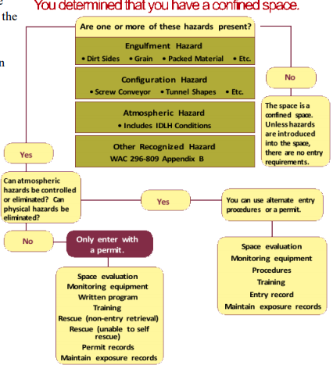

Appendix F
Non-Mandatory Permit Sample Confined Space Entry Permits
Use with Chapter 296-809 WAC, Confined Spaces
The following three confined space entry permits can be modified to fit your particular entry.
Print out the pages of the particular sample that you need and fill in the form. Make sure you use the appropriate portions of the forms to create your own entry permit.
To design your own entry permit, see WAC 296-809-50004. Use an entry permit that contains all the required information.
Example permits are listed on the following pages.

CONFINED SPACE ENTRY PERMIT Sample 1
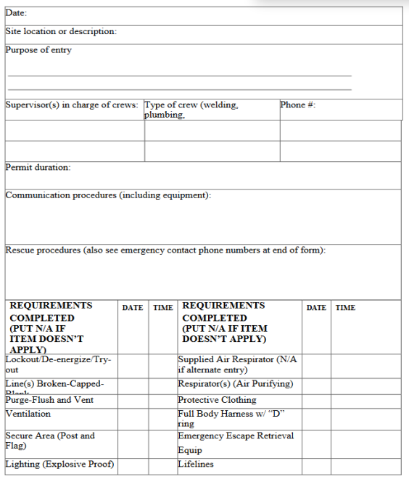

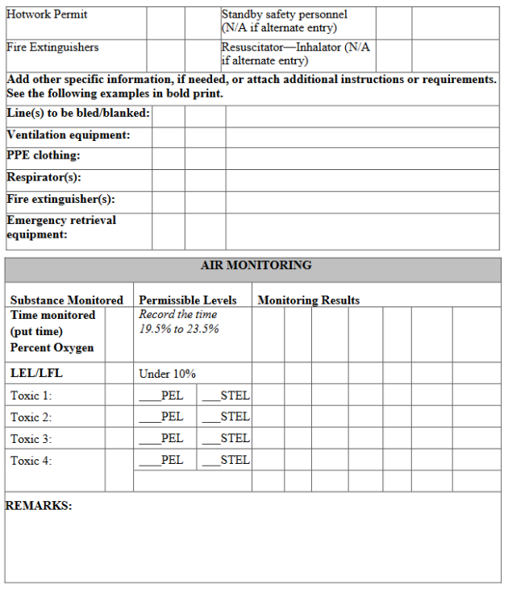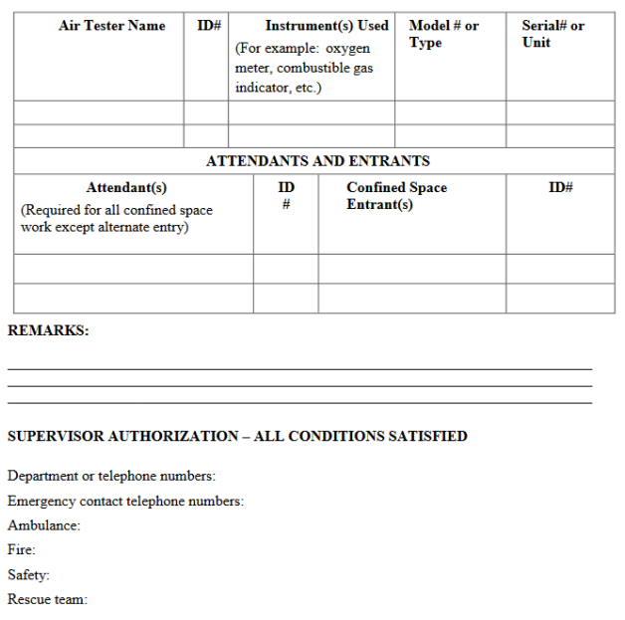

CONFINED SPACE ENTRY PERMIT Sample 2
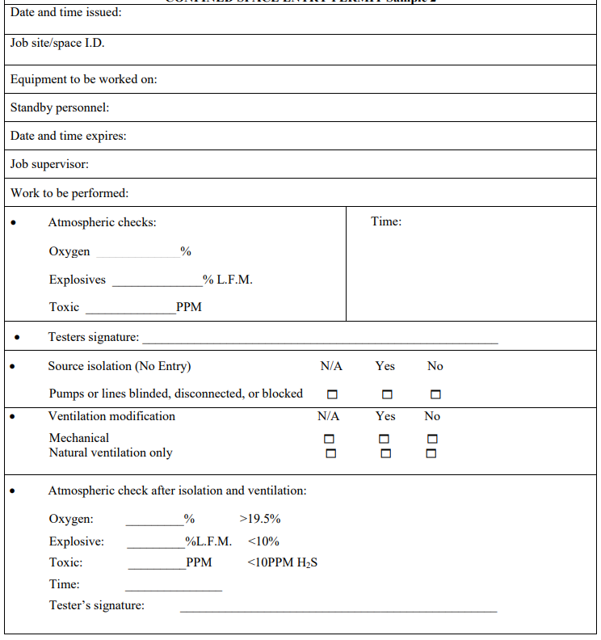

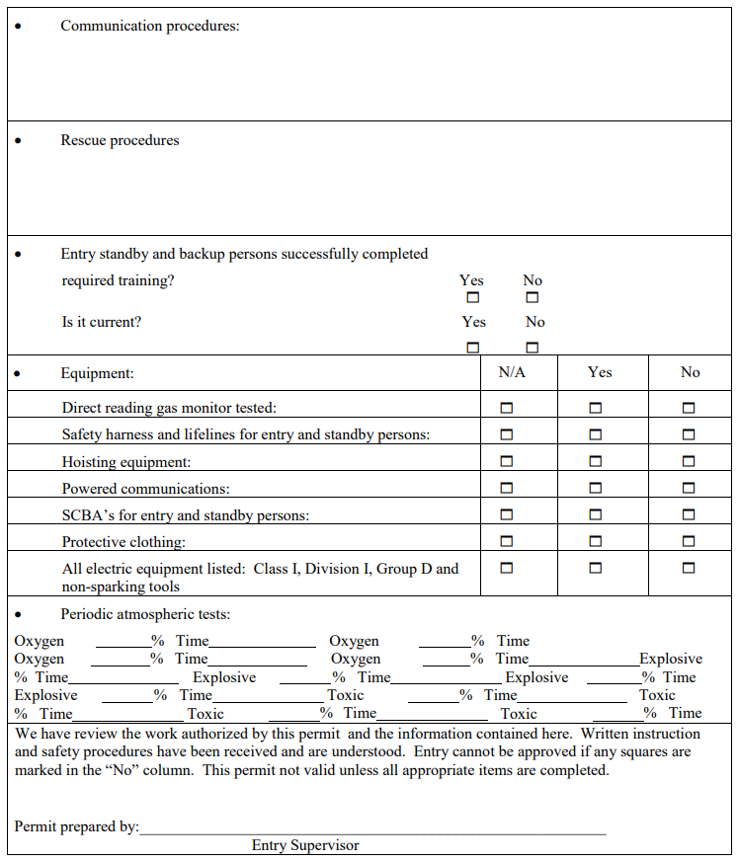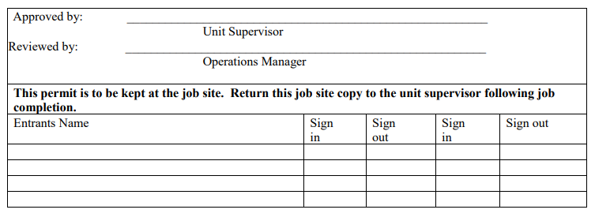

CONFINED SPACE ENTRY PERMIT Sample 3
