Hearing Loss Prevention Program
WAC 296-817

Purpose
This Hearing Loss Prevention Program is designed to protect employees from the effects of exposure to excessive noise at (add company name here) and comply with the WISHA Hearing Loss Prevention Rule (Noise) WAC 296-817. This chart below defines the different noise levels and their requirements:
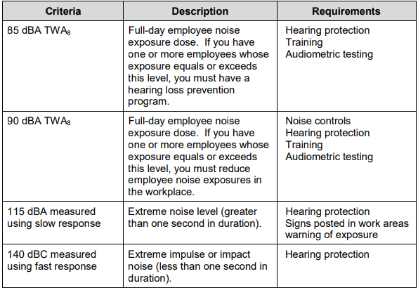

Noise Areas and Measurements
Noise measurements were taken of the following areas or equipment at our plant or workplace:
Area, equipment or job duties | Noise level in decibels | Date measured

Noise level measurements were taken with (enter type of instrument here) or by (private noise consultant or L&I consultant).
The following hearing protection is provided to employees at <<COMPANYNAME>>. Employees will be allowed to select their choice of hearing protection in the size that fits them correctly.
Type of hearing protection -foam, over ear, etc. | Brand name of hearing protection | Sizes available

Hearing protection is available from the following person(s) or at the following locations:

Hearing protection is required in the following locations, job duties or when the following equipment is used:

Audiometric testing will be provided at no cost to all employees whose noise exposure equals or exceeds an 8-hour average of 85 decibels in these parts of our shop:

Optional: (some employers decide or find it easier to cover all employees who might be overexposed to high noise sometime during their employment)
In addition, audiometric testing will also be provided to all employees working in the following areas or in the following job classifications:

Audiometric testing will be provided upon first assignment to a high noise area or within 180 days of assignment. These initial test results are the baseline results. Annual testing following these initial tests will be compared to the baseline test results for all employees who continue to work in high noise areas.
<<COMPANYHR>> will schedule audiometric testing for employees
For baseline tests, employees will be instructed to avoid unprotected exposure to high noise levels at least 14 hours before testing is done.
If a standard threshold shift (a drop in hearing ability of at least 10 decibels in three frequencies – 2000, 3000 or 4000 hertz) is found, the employee may be retested within 30 days.
Employees will be provided with results of their individual audiometric exams. If a standard threshold shift is found, employees will be notified in writing within 21 days of determination.
If a standard threshold shift if found in any employees, the following will also be done:
- The employee not wearing hearing protection will be provided them.
- The employee already using hearing protection will be re-fitted and re-trained.
- The employee will be referred to audiologist or ear, nose & throat specialist for further evaluation.
- The employee will be informed of a need for an ear exam if a medical cause unrelated to noise exposure is suspected.
Audiometric testing will be conducted by a licensed or certified audiologist, ear, nose & throat physician (otolaryngologist) or audiology technician certified by the Council of Accreditation in Occupational Hearing Conservation (CAOHC). Audiometric testing is conducted by (Customize by adding name of vendor or clinic).
Training will be provided to all employees exposed to noise above an 8-hour average of 85 decibels and will cover the following topics:
- The effects of noise on hearing
- The purpose of hearing protectors, the advantage and disadvantages of various types, and instructions on how to use and care for them,
- The purpose of audiometric testing and how it is done,
- Employee access to records.
Our training program is described as follows:

For questions related to noise or audiometric testing, employees can see <<COMPANYHR>>.

Access to Records
Personal audiometric exam results will be given or mailed directly to individual employees tested.
Noise measurement records can be viewed at the following location(s) or obtained from the following person(s):

