Respiratory Protection Program
WAC 296-842
Our respirator program administrator is <<COMPANYHR>>
Our administrator’s duties are to oversee the development of the respiratory program and make sure it is carried out at the workplace. The administrator will also evaluate the program regularly to make sure procedures are followed, respirator use is monitored, and respirators continue to provide adequate protection when job conditions change. Employees that voluntarily use respirators, see this document.

Selection of Respirators
We have evaluated our use of chemicals at this facility and found respirators must be used by employees in the following locations or positions or doing the following duties, tasks or activities:

Employee position or activity | Chemicals or products used | NIOSH approved respirators assigned | When used (routinely, infrequently, or in emergencies)
For information on how to select proper respirators for particular chemical exposures, click here
For information on how to evaluate employee exposure to chemicals, click here.

We selected these respirators based on the following information: [optional: attach air sampling results that show where respirators are required]
_________________________________________________________________________________________________________________________________________________________________________________________________________________________________________________________________________________________________________________________________________________________________________________________________________________________________________

Medical Evaluations
Every employee of this company who must wear a respirator will be provided with a medical evaluation before they are allowed to use the respirator. Our first step is to give the attached medical questionnaire within this document to those employees. Employees are required to fill out the questionnaire in private and send or give them to (Customize with name of medical provider). Our non-readers or non-English-reading employees will be assisted by (Customize with name of person who will assist). Completed questionnaires are confidential and will be sent directly to the medical provider without review by management.
If the medical questionnaire indicates to the medical provider that a further medical exam is required, this will be provided at no cost to our employees by (Customize with name of medical provider). We will get a recommendation from this medical provider on whether or not the employee is medically able to wear a respirator.
Additional medical evaluations will be done in the following situations:
- the medical provider recommends it,
- our respirator program administrator sees that the employee is having a medical problem during workplace respirator,
- an employee shows signs of breathing difficulty,
- changes in work conditions that increase employee physical stress (such as high temperatures or greater physical exertion).
Click here for a copy of the required medical questionnaire.
Click here for copy of information to provide to medical provider.

Respirator Fit Testing
All employees who wear tight-fitting respirators will be fit tested before using their respirator or given a new one. Fit testing will be repeated annually. Fit testing will also be done:
- when a different type of respirator or facepiece is chosen,
- when there is a physical change in an employee’s face that would affect fit,
- when our employees or the medical provider notify us that the fit is unacceptable.
No facial hair is to interfere with the seal between the skin and the respirator. Respirators are chosen for fit testing following procedures in the WISHA Respirators Rule (Table 11). Fit testing is not required for loose-fitting, positive pressure (supplied air helmet or hood style) respirators. We do fit-testing using one or more of the following fit-testing protocols (circle protocol you use) or quantitative fit-testing instrument (fill in):
- Irritant smoke protocol
- Banana Oil (isoamyl acetate) protocol
- Bitrex protocol
- Saccharin protocol
The quantitative fit-testing instrument we use is: _______________________________________________________________
Note: respirator vendors usually sell these instruments. While expensive, they can simplify fit testing.
Note: Click on the protocols above to view the several acceptable fit-testing procedures that come directly from the respiratory protection standard. It is your choice which procedure or fit-testing equipment to use. Some respirator vendors or occupational health clinics may do fit testing for you.
Documentation of our fit-testing results (Customize with location of documentation) _________________________________________________________________
Click here for a sample fit-test record form.
Our respirators will be checked for proper sealing by the user whenever the respirator is first put on, using the attached seal check procedures:
Click here for seal check procedures.

Respirator storage, cleaning, maintenance and repair
Our non-disposable respirators will be stored in the following clean locations:

Respirators will be cleaned and sanitized every (____) days or whenever they are visibly dirty (does not apply to paper dust masks which are disposed daily). Respirators will be cleaned according to the attached instructions (either the manufacturer’s instructions or the Respirators Rule cleaning procedures.)
For Rule-specified respirator cleaning procedures where you don’t have manufacturer’s instructions, click here.
All respirators will be inspected before and after every use and during cleaning. In addition, emergency respirators and self-contained tank-type supplied air respirators in storage will be inspected monthly.
Respirators will be inspected for damage, deterioration or improper functioning and repaired or replaced as needed. Repairs and adjustments are done by (Customize with name of person who maintains respirators) who is trained in respirator maintenance and repair. Supplied air respirators will be checked for proper functioning of regulator and warning devices and amount of air in tanks where used.
When supplied air respirators are used, any needed repairs or adjustments will be done by the manufacturer or technician trained by the manufacturer. Our supplied air respirators are maintained and repaired by (Customize with name of vendor or technician).
On respirators with vapor or gas cartridges, the cartridges will be regularly replaced on the following schedule:
Check with respirator vendor for recommended replacement schedule for each brand and type of respirator.
Type of respirator cartridge | Location or job duties | Chemicals in use | Replacement schedule

Respirator Use
The Program Administrator will monitor the work area to be aware of changing conditions where employees are using respirators.
Employees will not be allowed to wear respirators with tight-fitting facepieces if they have facial hair (e.g., stubble, bangs) absence of normally worn dentures, facial deformities (e.g., scars, deep skin creases, prominent cheekbones), or other facial features that interfere with the face piece seal or valve function. Jewelry or headgear that projects under the face piece seal is also not allowed.
If corrective glasses or other personal protective equipment is worn, it will not interfere with the seal of the face piece to the face.
Note: Full-face piece respirators can be provided with corrective glasses since corrective lenses can be mounted inside a full-face piece respirator. Contact lenses can also be used with full face piece respirators if they do not cause any problems for the employee.
A seal check will be performed every time a tight-fitting respirator is put on.
The program administrator will make sure that the NIOSH labels and color-coding on respirator filters and cartridges remain readable and intact during use.
Employees will leave the area where respirators are required for any of the following reasons:
- to replace filters or cartridges
- when they smell or taste a chemical inside the respirator
- when they notice a change in breathing resistance
- to adjust their respirator
- to wash their faces or respirator
- if they become ill
- if they experience dizziness, nausea, weakness, breathing difficulty, coughing, sneezing vomiting, fever or chills
The Program Administrator has identified the following areas or job duties as presenting the potential for IDLH (immediately dangerous to life or health) conditions:

Where any area or Confined Space is designated as IDLH, we will provide (Customize with number of standby employees – generally 1 or 2) standby employees outside the area. These standby employees are trained in effective emergency rescue, are equipped with pressure-demand self-contained breathing apparatus (SCBAs), and will be in constant visual, voice or signal line communication with the employees in the IDLH area. The standby employees will notify the administrator before entering the IDLH area, and we will provide the necessary assistance when notified.
Click here for criteria for one or two standby employees.
Breathing Air Quality for Supplied Air Respirators (if used)
Only Grade D breathing air will be supplied to compressed air tanks for respirators.
Click here for description of Grade D breathing air. (WAC 296-842-20005)
Our compressors used for breathing air supply are non-oil lubricated and the air intake is located in an uncontaminated area. The brand name of our air compressor(s) and the location is as follows:

Our compressors are equipped with filters, water traps and sorbents to provide clean, safe air. They are maintained by (Customize with name of maintainer).
Maintenance records are located at (Customize with location of records).
Optional: We use oil-lubricated compressor(s) used for breathing air. These compressor(s) are equipped with carbon-monoxide alarms, high-temperature alarms or both. They are located at (Customize with location of compressors).
Periodic carbon monoxide monitoring is done by (Customize with who does CM Monitoring) on the following schedule on our compressor(s) with no carbon monoxide alarm:
_____________________________________________________________________________________
If used, our airline respirators are equipped with air couplings that are not compatible with couplings to non-respirable air (plant air for example) or other gas systems.
If used, our air cylinders for supplied air respirators are inspected and tested according to federal DOT regulations.

Respirator Training
Training is done by (Customize with name of trainer) before employees wear their respirators and annually thereafter as long as they wear respirators. Our supervisors or crew bosses who wear respirators or supervise employees who do, will also be trained on the same schedule.
Additional training will also be done when an employee uses a different type of respirator or workplace conditions affecting respiratory hazards or respirator use have changed.
Training will cover the following topics:
- Why the respirator is necessary,
- The respirator’s capabilities and limitations,
- How improper fit, use or maintenance can make the respirator ineffective,
- How to properly inspect, put on, seal check, use, and remove the respirator,
- How to clean, repair and store the respirator or get it done by someone else,
- How to use a respirator in an emergency situation or when it fails,
- Medical symptoms that may limit or prevent respirator use,
- Our obligations under the Respirators Rule.
Our training program is attached.
Click here for sample respirator training record form.

Respiratory Program Evaluation
We evaluate our respiratory program for effectiveness by doing the following steps:
- Checking results of fit-test results and health provider evaluations.
- Talking with employees who wear respirators about their respirators – how they fit, do they feel they are adequately protecting them, do they notice any difficulties in breathing while wearing them, do they notice any odors while wearing them, etc.
- Periodically checking employee job duties for changes in chemical exposure.
- Periodically checking maintenance and storage of respirators.
- Periodically checking how employees use their respirators.
- Other ____________________________________________________________

Recordkeeping
The following records will be kept:
- A copy of this completed respirator program
- Employees’ latest fit-testing results
- Employee training records
- Written recommendations from the medical provider
The records will be kept at the following location: (Customize with location of records)
Employees will have access to these records.

End of Sample Program
The following pages are informational pages or forms you can use as attachments to the sample program. Links to these are provided in the sample program.

How to Select the Correct Respirator
The type and brands of respirators vary widely ranging from simple dust masks to supplied air respirators like the kind firemen wear. Following is description of the main types of respirators.
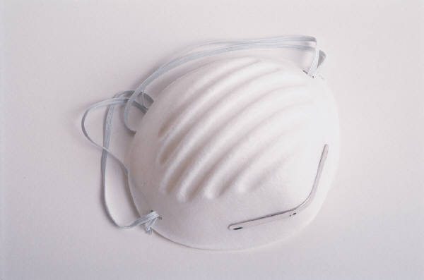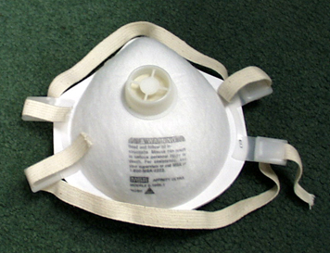

Dust Masks (filtering face pieces)
These simple, two-strap disposable dust masks are designed only for dusts. They are not as protective as other respirators, but do an adequate job in many cases, unless the dust is really toxic or copious. Don’t confuse these two-strap masks with the less protective one-strap dust mask designed only for pollen or non-toxic dust.
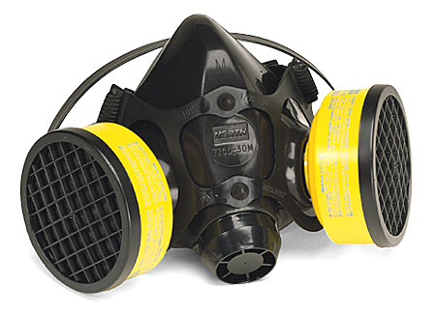

Half-Face Air-Purifying Respirator
These respirators are sometimes called “half-face” or “half-mask” respirators since they cover just the nose and mouth. They have removable cartridges that filter out either dust, chemicals or both. Selecting the correct cartridges is essential since they are designed for particular types of chemicals or dust. A reputable respirator vendor can assist you in selecting the correct cartridges. These cartridges are typically removable and sometimes interchangeable. Cartridges are available for solvents, ammonia, chlorine, acids and other chemicals. The cartridges must be changed out or replaced periodically, especially for chemicals, since they can absorb only so much contaminant before breakthrough occurs. A few cartridges are equipped with end-of-service indicators that show when a cartridge should be replaced. Most cartridges don’t have this indicator and you must develop a change-out schedule to prevent breakthrough. The change-out schedule is based on the chemical concentration, physical work effort, temperature and humidity. Many respirator manufacturers have cartridge change schedule calculators available on the Internet.
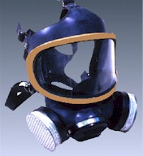

Full-Face Air-Purifying Respirator
In some situations, you may need or want to use full-face respirators. This type of respirator is used when the air contaminant irritates the eyes. They also provide somewhat higher protection to the lungs since they tend to fit tighter and are less prone to leaking. These respirators also have replaceable cartridges that must be changed on a regular basis as described above for half-face respirators.
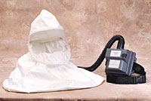

Powered Air Purifying Respirator (PAPR)
Powered Air Purifying Respirators have a battery pack that draws air through replaceable cartridges and blows into a full face piece, helmet or hood. These respirators are often more comfortable in hot weather, and some can provide more protection, depending on the type. The cartridges must be changed regularly as describe for half-face respirators above.
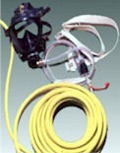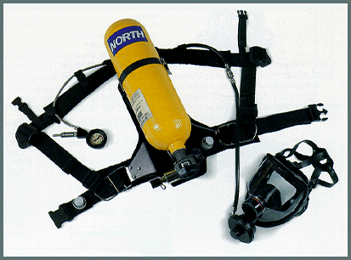
Airline Respirator Tank-type respirator (SCBA)

Supplied Air Respirators and Self-Contained Breathing Apparatus (SCBA)
In a few situations, you may need to provide a supplied air respirator to your employees. These situations include large chemical spills or leaks, entering a confined space where there is lack of oxygen or high levels of air contaminants, or working around extremely toxic chemicals. They may also be necessary working at hazardous waste sites, during sandblasting or in some spray painting operations. “Supplied air,” means that clean air is provided by means of an air hose from a compressor or a pressurized air tank.
Supplied air respirators are required when a respiratory hazard is considered “immediately dangerous to life or health” (also called “IDLH”). Respiratory hazards are classified as IDLH as follows:
- There is a lack of oxygen (less than 19.5% oxygen)
- There is too much oxygen (more than 23.5% - a fire hazard)
- You know there are toxic chemicals in the air, but you don’t know how much
- The amount of chemical in the air is known or expected to be above the IDLH level for that chemical. See the NIOSH Pocket Guide to Chemical Hazards for chemical IDLH levels.
Levels of chemicals above IDLH can occur in confined spaces, or enclosed spaces where there is little or no ventilation.

Emergency Escape Respirators
Emergency escape respirators, as the name implies, can only be used for one thing – to escape or exit from a room or building in an emergency, usually a large chemical release, leak or spill, or when a supplied air respirator fails or runs out of air. An escape respirator is typically a small bottle or tank of air connected to a face piece that supplies 5-10 minutes of air. Some supplied air respirators will have an auxiliary bottle of air for escape that connects to the existing face piece.
How do you decide which type of respirator to select? First, it must be the correct type for the air contaminant. Second, it must fit properly. Third, it must provide adequate protection for the amount of chemical in the air. The more toxic or more concentrated the chemical is in the air, the higher the level of protection the respirator must provide.

Different respirators provide different protection. Depending on the amount of chemical in the air, you may need to use a respirator that provides more protection. Respirators are rated by their “assigned protection factor” (APF) which is a number between 10 and 10,000. The higher the number, the greater the protection. A respirator with a protection factor of 10 will provide adequate protection to levels of the chemical in the air 10 times the safe limit of that chemical. See Table 5 below.
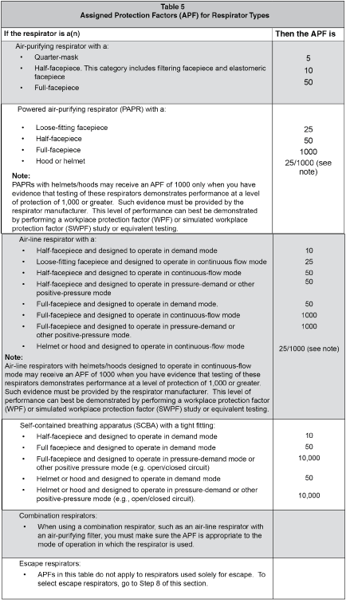
Use Table 6 below to select air-purifying respirators for particle, vapor, or gas contaminants.
Table 6
Requirements for Selecting Air-purifying Respirators
If the contaminant is a: | Then
Gas or vapor | Provide a respirator with canisters or cartridges equipped with a NIOSH-certified, end-of-service-life indicator (ESLI) (note: there just a few of these)  or  If a canister or cartridge with an ESLI is not available, develop a cartridge change schedule to make sure the canisters or cartridges are replaced before they are no longer effective (note: most cartridge respirators fit in this category)  or  Select an air-supplying respirator
Particle, such as a dust, spray, mist, fog, fume, or aerosol | Select respirators with filters certified to be at least 95% efficient by NIOSH. For example, N95s, R99s, P100s, or High Efficiency Particulate Air filters (HEPA)  Or  You may select respirators NIOSH certified as “dust and mist,” “dust, fume, or mist,” or “pesticides.” You can only use these respirators if particles primarily have a mass median aerodynamic diameter of at least 2 micrometers Note: These latter respirators are no longer sold for occupational use, but some employers may still be using them.

How to Evaluate your Workplace for Employee Exposure to Chemicals
Respirators are required when employees are exposed (can inhale) chemicals or dust in the air that are at harmful levels. These can include vapors from handling solvents, spray-painting, dust from grinding or sanding, or welding fumes. If you manage a small business, you are probably quite familiar with each employee’s job, what chemicals they use or how much welding, spray painting, grinding or sanding they do. Your employees may have told you that the chemical odors or dust bothered them or that they were worried about their chemical exposure. You may have switched to less hazardous chemicals. Or you may have no alternative but to use more hazardous chemicals to do the job or make your product. But without some knowledge of the amount of chemical or dust in the air in the workplace, you cannot know whether your employees are exposed to harmful amounts of chemicals they use.
Just about every chemical has its toxic amount or level that will make person sick. Even too much table salt can be harmful. On the other hand, highly toxic chemicals can be used without harm to employees if handled properly. Most commonly used chemicals have safe limits or “permissible exposure limits” in the air that if exceeded will cause harm. If these limits are exceeded, you are required to take steps to protect your employees from that air exposure. If the levels cannot be reduced below the permissible exposure limits by ventilation, changes in the process or reduction in the length of time of exposure, then you must provide respirators to exposed employees.
The best way to accurately determine the levels of chemicals or dust in the air is to do some type of air sampling. There are a variety of instruments and devices for measuring air contaminants. Some are simple and cheap, most are quite expensive. The methods for doing the air sampling accurately are usually fairly complicated and should not be done by a layperson. Air sampling can be done by WISHA industrial hygiene consultants at your request. This is a free service and will not result in a citation or penalty or a report to WISHA safety inspectors. To request this service, contact the nearest Department of Labor & Industries Office near you. Click here for contact information. You can also have a private industrial hygiene consultant conduct air sampling. They can be found under “industrial hygiene services” in the Yellow Pages.
If you belong to a trade association or industry group, that organization may have information on common chemical hazards and methods of controls. The material safety data sheets for products used also provide information about the hazards of the chemicals, permissible exposure limits, methods of controls and recommended respirators.

Sample Respirator Fit Test Record
Name: __________________________________________________ Initials: ________
Type of qualitative/quantitative fit test used: _________________________________
Name of test operator: _____________________________________ Initials: _______
Date: _________________
Respirator Mfr./Model/Approval no. Size Pass/Fail or Fit Factor
Note: “Fit factor” is numerical result of quantitative fit test from instrument reading

1. _______________________________________ S M L P F _____
2. _______________________________________ S M L P F _____
3. _______________________________________ S M L P F _____
4. _______________________________________ S M L P F _____
Clean Shaven? Yes___ No___ (Fit-test cannot be done unless clean-shaven)
Medical Evaluation Completed? Yes___ No___
NOTES: _____________________________________________________________

____________________________________________________________________

____________________________________________________________________

____________________________________________________________________

This record indicates that you have passed or failed a qualitative or quantitative fit test as shown above for the particular respirator(s) shown. Other types will not be used until fit tested.

Respirator Training Record

___________________________________________ Employee Name (printed)
I certify that I have been trained in the use of the following respirator(s):
_____________________________________________________________________________________
_____________________________________________________________________________________
_____________________________________________________________________________________
_____________________________________________________________________________________
This training included the inspection procedures, fitting, maintenance and limitations of the above respirator(s). I understand how the respirator operates and provides protection. I further certify that I have heard the explanation of the respirator(s) as described above and I understand the instructions relevant to use, cleaning, disinfecting and the limitations of the respirator(s).

__________________________________
Employee Signature

__________________________________
Instructor Signature

__________________________________
Date

Employer-Provided Information for Medical Evaluations
This form may be used by the employer to give to your medical provider, information on respirator uses by your employees, but it is not a required form. You can also consult directly with your medical provider and discuss the information below.
You must also give the medical provider a copy of your written respiratory program and copy of the Respirators Rule

Specific Respirator Use Information

Employee Name: ___________________________________________
Company name: _______________________________________________
Employee job title: __________________________________________
Company Address: ___________________________________________
Company contact person and phone #:_______________________________
1. Will the employee be wearing protective clothing and/or equipment (other than the respirator) when using the respirator?
Yes/No _______ If “Yes,” describe protective clothing and/or equipment:
_____________________________________________________________________________________
_____________________________________________________________________________________
_____________________________________________________________________________________
2. Will employee be working under hot conditions (temperature exceeding 77°F)?
Yes/No ________ If “Yes”, describe nature of work and duration:
_____________________________________________________________________________________
_____________________________________________________________________________________
_____________________________________________________________________________________
3. Will employee be working under humid conditions? Yes / No_______
4. Describe any special or hazardous conditions the employee could encounter when using the respirator (for example, confined spaces, life-threatening gases).
_____________________________________________________________________________________
_____________________________________________________________________________________
_____________________________________________________________________________________

Specific Respirator Use Information continued

Check Box | Respirator Type | Face / Head Cover Type  (half or full face, helmet, or hood) | Frequency of Use  (hours per day, week, or month) | Work Effort  Light, Moderate, Heavy  (see descriptions below) | Respirator Wt.
 | Disposable face piece particulate filter  (N, R or P series) | 1/2 face piece
 | Mask with replaceable filter or cartridge
 | Mask with canister
 | Powered air-purifying respirator (PAPR)
 | Air line, continuous flow
 | Air line, negative pressure demand
 | Air line, positive pressure demand
 | SCBA, negative pressure demand | Full face piece
 | SCBA, positive pressure demand | Full face piece

Employee Background Information Form
1. Today's date:
2. Your name:
3. Your age (to nearest year):

Part 1 - Employee Background Information ALL employees must complete this part
Please print
4. Gender (circle one): Male / Female / Nonbinary / Other
5. Your height: ft. in.
6. Your weight: lbs.
7. Your job title:
8. A phone number where you can be reached by the health care professional who reviews this questionnaire (include Area Code):
9. The best time to call you at this number:
10. Has your employer told you how to contact the health care professional who will review this questionnaire? Yes/No
11. Check the type of respirator(s) you will be using:
a. _______N, R, or P filtering-facepiece respirator (for example, a dust mask, OR an N95 filtering-facepiece respirator).
b. Check all that apply.
- Half mask
- Full facepiece mask
- Helmet hood
- Escape
- Nonpowered cartridge or canister
- Powered air-purifying cartridge respirator (PAPR)
- Supplied-air or Air-line
- Self-contained breathing apparatus (SCBA): Demand or Pressure demand
- Other:
12. Have you previously worn a respirator? Yes/No
If “yes,” describe what type(s):

Part 2 - General Health Information ALL employees must complete this part
Please circle “Yes” or “No”
- 1. Do you currently smoke tobacco, or have you smoked tobacco in the last month? Yes/No
- Have you ever had any of the following conditions?
  - Seizures (fits): Yes/No
  - Diabetes (sugar disease): Yes/No
  - Allergic reactions that interfere with your breathing: Yes/No
  - Claustrophobia (fear of closed-in places): Yes/No
  - Trouble smelling odors: Yes/No
- Have you ever had any of the following pulmonary or lung problems?
  - Asbestosis: Yes/No
  - Asthma: Yes/No
  - Chronic bronchitis: Yes/No
  - Emphysema: Yes/No
  - Pneumonia: Yes/No
  - Tuberculosis: Yes/No
  - Silicosis: Yes/No
  - Pneumothorax (collapsed lung): Yes/No
  - Lung cancer: Yes/No
  - Broken ribs: Yes/No
  - Any chest injuries or surgeries: Yes/No
  - Any other lung problem that you have been told about: Yes/No
- Do you currently have any of the following symptoms of pulmonary or lung illness?
  - Shortness of breath: Yes/No
  - Shortness of breath when walking fast on level ground or walking up a slight hill or incline: Yes/No
  - Shortness of breath when walking with other people at an ordinary pace on level ground: Yes/No
  - Have to stop for breath when walking at your own pace on level ground: Yes/No
  - Shortness of breath when washing or dressing yourself: Yes/No
  - Shortness of breath that interferes with your job: Yes/No
  - Coughing that produces phlegm (thick sputum): Yes/No
  - Coughing that wakes you early in the morning: Yes/No
  - Coughing that occurs mostly when you are lying down: Yes/No
  - Coughing up blood in the last month: Yes/No
  - Wheezing: Yes/No
  - Wheezing that interferes with your job: Yes/No
  - Chest pain when you breathe deeply: Yes/No
  - Any other symptoms that you think may be related to lung problems: Yes/No
- Have you ever had any of the following cardiovascular or heart problems? Yes/No
  - Heart attack: Yes/No
  - Stroke: Yes/No
  - Angina: Yes/No
  - Heart failure: Yes/No
  - Swelling in your legs or feet (not caused by walking): Yes/No
  - Heart arrhythmia (heart beating irregularly): Yes/No
  - High blood pressure: Yes/No
  - Any other heart problem that you have been told about: Yes/No
- Have you ever had any of the following cardiovascular or heart symptoms? Yes/No
  - Frequent pain or tightness in your chest: Yes/No
  - Pain or tightness in your chest during physical activity: Yes/No
  - Pain or tightness in your chest that interferes with your job: Yes /No
  - In the past 2 years, have you noticed your heart skipping or missing a beat: Yes/No
  - Heartburn or indigestion that is not related to eating: Yes/No
  - Any other symptoms that you think may be related to heart or circulation problems: Yes/No
- Do you currently take medication for any of the following problems? Yes/No
  - Breathing or lung problems: Yes/No
  - Heart trouble: Yes/No
  - Blood pressure: Yes/No
  - Seizures (fits): Yes/No
- If you have used a respirator, have you ever had any of the following problems? (If you have never used a respirator, check the following space and go to question 9)
  - Eye irritation: Yes/No
  - Skin allergies or rashes: Yes/No
  - Anxiety: Yes/No
  - General weakness or fatigue: Yes/No
  - Any other problem that interferes with your use of a respirator? Yes/No
- Would you like to talk to the health care professional who will review this questionnaire about your answers? Yes/No

Part 3 - Additional Questions for Users of Full-Facepiece Respirators or SCBAs
Please circle “Yes” or “No”
- Have you ever lost vision in either eye (temporarily or permanently)? Yes/No
- Do you currently have any of these vision problems?
  - Need to wear contact lenses: Yes/No
  - Need to wear glasses: Yes/No
  - Color blindness: Yes/No
  - Any other eye or vision problem: Yes/No
- Have you ever had an injury to your ears, including a broken ear drum? Yes/No
- Do you currently have any of these hearing problems?
  - Difficulty hearing: Yes/No
  - Need to wear a hearing aid: Yes/No
  - Any other hearing or ear problem: Yes/No
- Have you ever had a back injury? Yes/No
- Do you currently have any of the following musculoskeletal problems?
  - Weakness in any of your arms, hands, legs, or feet: Yes/No
  - Back pain: Yes/No
  - Difficulty fully moving your arms and legs: Yes/No
  - Pain or stiffness when you lean forward or backward at the waist: Yes/No
  - Difficulty fully moving your head up or down: Yes/No
  - Difficulty fully moving your head side to side: Yes/No
  - Difficulty bending at your knees: Yes/No
  - Difficulty squatting to the ground: Yes/No
  - Climbing a flight of stairs or a ladder carrying more than 25 lbs: Yes/No
  - Any other muscle or skeletal problem that interferes with using a respirator: Yes/No

Part 4 - Discretionary Questions
Complete questions in this part ONLY IF your employer's health care provider says they are necessary
- In your present job, are you working at high altitudes (over 5,000 feet) or in a place that has lower than normal amounts of oxygen? Yes/No
  - If “yes,” do you have feelings of dizziness, shortness of breath, pounding in your chest, or other symptoms when you are working under these conditions? Yes/No
- Have you ever been exposed (at work or home) to hazardous solvents, hazardous airborne chemicals (such as gases, fumes, or dust), OR have you come into skin contact with hazardous chemicals? Yes/No
  - If “yes,” name the chemicals, if you know them:
- Have you ever worked with any of the materials, or under any of the conditions, listed below:
  - Asbestos? Yes/No
  - Silica (for example, in sandblasting)? Yes/No
  - Tungsten/cobalt (for example, grinding or welding this material)? Yes/No
  - Beryllium? Yes/No
  - Aluminum? Yes/No
  - Coal (for example, mining)? Yes/No
  - Iron? Yes/No
  - Tin? Yes/No
  - Dusty environments? Yes/No
  - Any other hazardous exposures? Yes/No
    - If “yes,” describe these exposures:
- List any second jobs or side businesses you have:
- List your previous occupations:
- List your current and previous hobbies:
- Have you been in the military services? Yes/No
  - If “yes,” were you exposed to biological or chemical agents (either in training or combat)? Yes/No
- Have you ever worked on a HAZMAT team? Yes/No
- Other than medications for breathing and lung problems, heart trouble, blood pressure, and seizures mentioned earlier in this questionnaire, are you taking any other medications for any reason (including over-the-counter medications)? Yes/No
  - If “yes,” name the medications if you know them:
- Will you be using any of the following items with your respirator(s)?
  - HEPA filters: Yes /No
  - Canisters (for example, gas masks): Yes/No
  - Cartridges: Yes/No
- How often are you expected to use the respirator(s)?
  - Escape-only (no rescue): Yes/No
  - Emergency rescue only: Yes/No
  - Less than 5 hours per week: Yes/No
  - Less than 2 hours per day: Yes/No
  - 2 to 4 hours per day: Yes/No
  - Over 4 hours per day: Yes/No
- During the period you are using the respirator(s), is your work effort:
  - Light (less than 200 kcal per hour): Yes/No
    - If “yes,” how long does this period last during the average shift: hrs. mins.
Examples of a light work effort are sitting while writing, typing, drafting, or performing light assembly work; or standing while operating drill press (1-3 lbs.) or controlling machines.
  - Moderate (200 to 350 kcal per hour): Yes/No
    - If “yes,” how long does this period last during the average shift: hrs. mins.
Examples of moderate work effort are sitting while nailing or filing; driving a truck or bus in urban traffic; standing while drilling, nailing, performing assembly work, or transferring a moderate load (about 35 lbs.) at trunk level; walking on a level surface about 2 mph or down a 5-degree grade about 3 mph; or pushing a wheelbarrow with a heavy load (about 100 lbs.) on a level surface.
  - Heavy (above 350 kcal per hour): Yes/No
    - If “yes,” how long does this period last during the average shift: hrs. mins.
Examples of heavy work are lifting a heavy load (about 50 lbs.) from the floor to your waist or shoulder; working on a loading dock; shoveling; standing while bricklaying or chipping castings; walking up an 8-degree grade about 2 mph; climbing stairs with a heavy load (about 50 lbs.).
- Will you be wearing protective clothing and/or equipment (other than the respirator) when you are using your respirator? Yes/No
  - If “yes,” describe this protective clothing and/or equipment:
- Will you be working under hot conditions (temperature exceeding 77°F): Yes/No
- Will you be working under humid conditions: Yes/No
- Describe the work you will be doing while using your respirator(s):
- Describe any special or hazardous conditions you might encounter when you are using your respirator(s) (for example, confined spaces, life-threatening gases):
- Provide the following information, if you know it, for each toxic substance that you will be exposed to when you are using your respirator(s):
  - Name of the first toxic substance:
    - Estimated maximum exposure level per shift:
    - Duration of exposure per shift:
  - Name of the second toxic substance:
    - Estimated maximum exposure level per shift:
    - Duration of exposure per shift:
  - Name of the third toxic substance:
    - Estimated maximum exposure level per shift:
    - Duration of exposure per shift:
  - The name of any other toxic substances that you will be exposed to while using your respirator:
- Describe any special responsibilities you will have while using your respirator(s) that may affect the safety and wellbeing of others (for example, rescue, security).

Work Effort Descriptions
Examples of a light work effort are sitting while writing, typing, drafting, or performing light assembly work; or standing while operating a drill press (1-3 lbs.) or controlling machines.
Examples of moderate work effort are sitting while nailing or filing; driving a truck or bus in urban traffic; standing while drilling, nailing, performing assembly work, or transferring a moderate load (about 35 lbs.) at trunk level; walking on a level surface about 2 mph or down a 5-degree grade about 3 mph; or pushing a wheelbarrow with a heavy load (about 100 lbs.) on a level surface.
Examples of heavy work effort are lifting a heavy load (about 50 lbs.) from the floor to your waist or shoulder; working on a loading dock; shoveling; standing; standing while bricklaying or chipping castings; walking up an 8-degree grade about 2 mph; climbing stairs with a heavy load (about 50 lb.).

Criteria for deciding whether one or two standby employees are needed at an Immediately Dangerous to Life or Health (IDLH) location
WAC 296-842-19005
Provide standby assistance in immediately dangerous to life or health (IDLH) conditions. You must:
- Provide at least 2 standby employees outside the IDLH area.
Note:
You need only one standby employee if the IDLH condition is well characterized, will remain stable and you can show one employee can adequately do all of the following:
  - Monitor employees in the IDLH area
  - Implement communication
  - Initiate rescue duties.

Procedure for Choosing a Respirator for Fit Testing
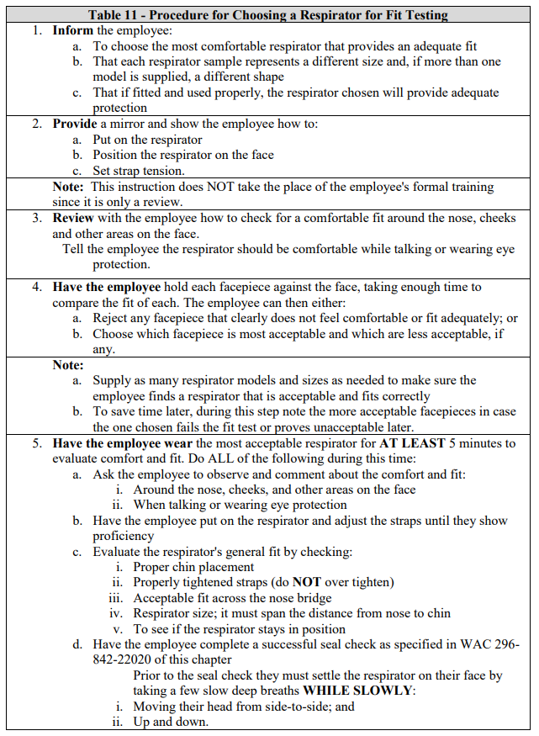

Seal Check Procedures (from Respirators Rule)

Respirator Cleaning Procedures (from Respirators Rule)

