(Your Logo here)

Propane Cylinder Filling
As an employee of (your company name), filling propane tanks may be part of your assigned duties, and you are required to adhere to all procedures, laws and regulations pertaining to filling propane cylinders. The following is the procedure is for filling propane cylinders. These procedures must always be followed when filling propane cylinders. Failure to comply with (your company name), Propane Cylinder Filling policy will result in disciplinary action up to, or including, employment suspension or termination.

At (your company name),, SAFETY is everyone’s responsibility, which means it is YOUR responsibility.

Step 1 Put on appropriate PPE of safety glasses and insulated rubber gloves. You are dealing with propane in a liquid state which is -50°F and will freeze exposed skin quickly. PPE is always to be worn while filling any propane tank.

Step 2 Check the date on the propane tank. Do not fill any tanks with a date older than 10 years. Follow the Standard Operating Procedure for Propane Cylinder Qualifications to properly identify the date on a tank. All tanks must be stamped with DOT (Department of Transportation).
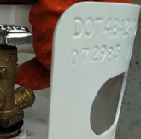
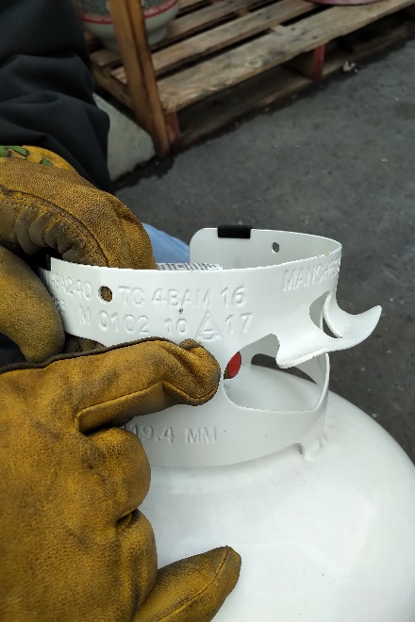

Step 3 In accordance with 49 CFR § 173.301(a)(2), cylinders must undergo a visual inspection prior to being filled. If any of the defects noted in items 1 through 4 below are present, the cylinder must not be filled and may only be repaired, requalified, or rebuilt by an authorized U.S. DOT facility (see authorized RIN and VIN holders below):
- Damage to the cylinder’s exterior including dents; bulges; cuts; or cracks on the cylinder’s surface, or to welds; and any evidence of physical abuse; fire; or heat damage.
- Detrimental rust, corrosion, or pitting on the cylinder, particularly on the bottom.
- Absence of/damage to a cylinder foot ring, cylinder neck ring (collar), or valve cover.
- A leaking or defective valve or leaking or defective pressure relief device. The face seal must be in good condition free from double sealing, gouging/tearing, roping or cracking.

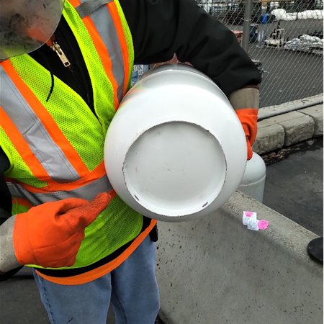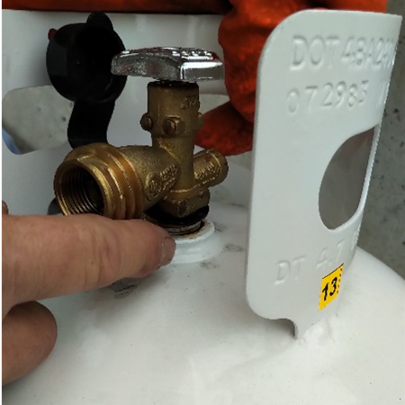
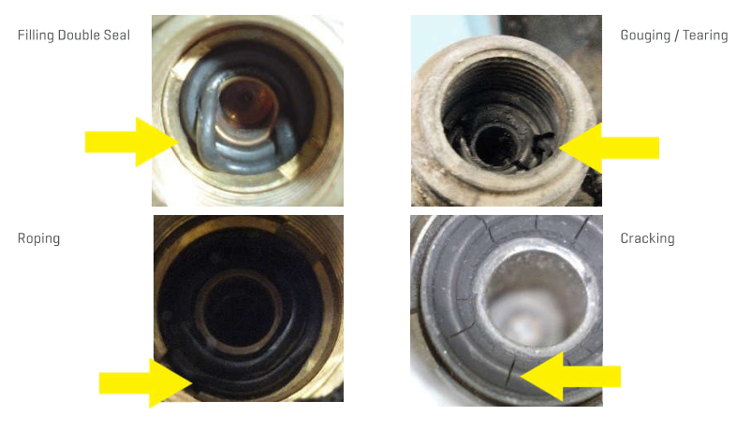

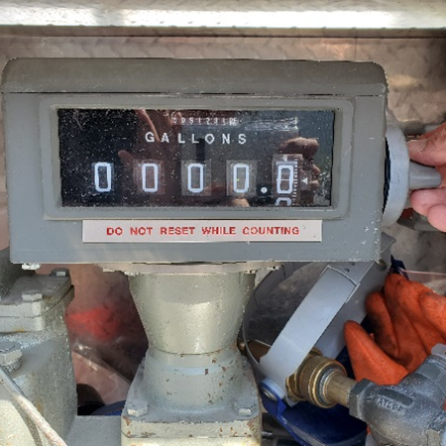
Step 4 Reset gallon meter on main propane tank to 0.

Step 5 Place tank on flat ground and Insert propane hose thread (counter clockwise) into propane tank valve.
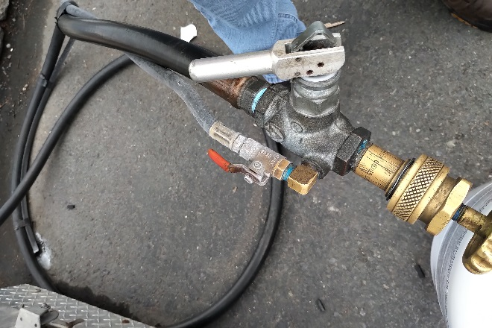
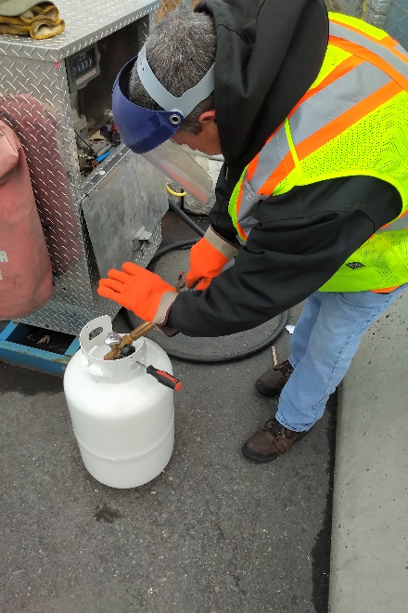

Step 6 Open main valve on the propane tank that is being filled.

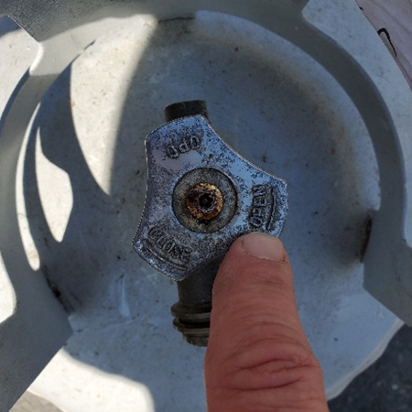

Step 7 Turn main unit on.

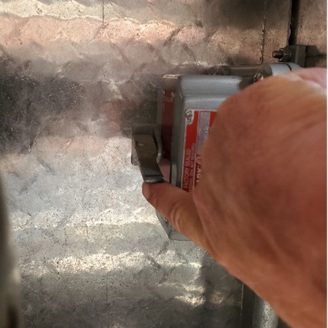

Step 8 Use flat tipped screwdriver to open pressure relief valve on the tank being filled.

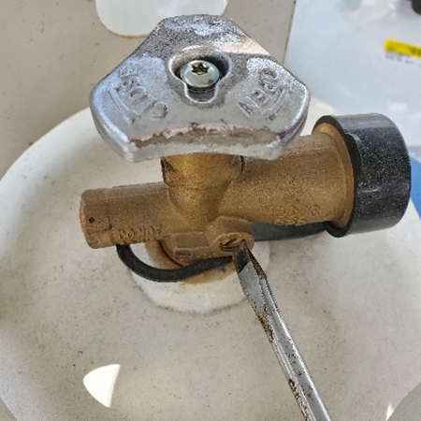

Step 9
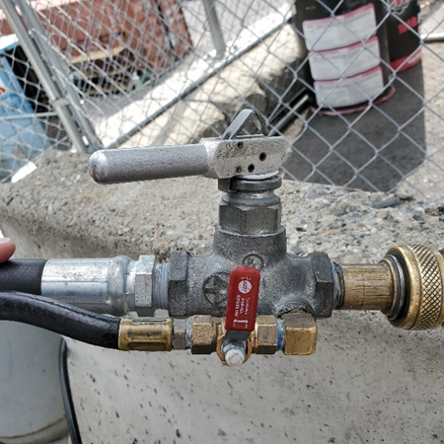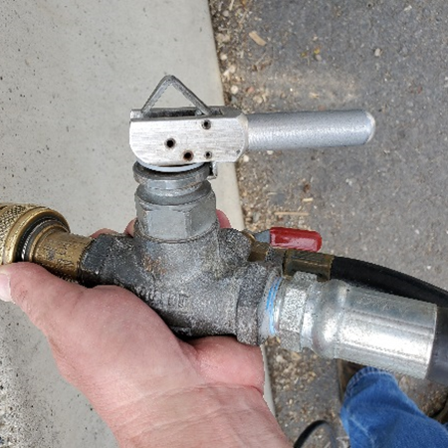
Make sure pressure relief valve is in closed position and then open valve on hose to start filling the tank.

Step 10 Make sure the gallon meter is moving and the tank is being filled with propane. (When the tank is full a steady stream of propane will emit from the pressure relief valve on the tank).

Step 11 Close pressure relief valve on the tank, shut valve on hose, close valve on tank and turn off main tank switch.
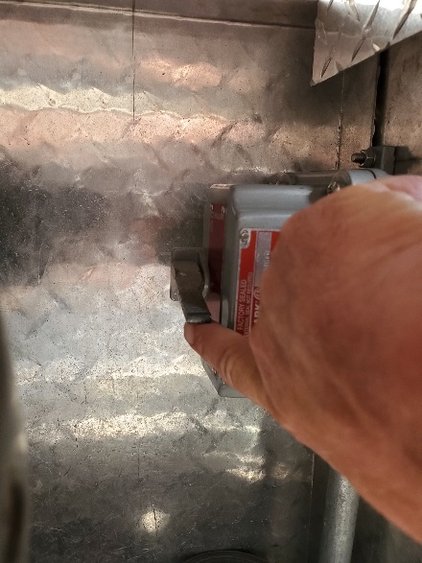

Step 12 Release pressure from hose by opening valve, then disconnect hose from tank (clockwise). Note how many gallons used and let the cashiers know. Put away hose and PPE and close door.

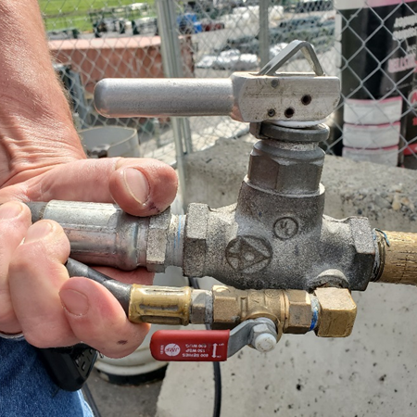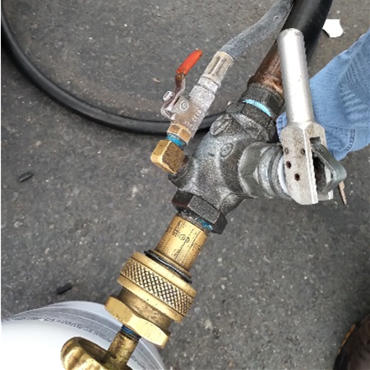

Standard Operating Procedure
PROPANE CYLINDER QUALIFICATIONS

As an employee of (your company name), filling propane tanks may be part of your assigned duties, and you are required to adhere to all laws and regulations pertaining to filling propane cylinders. The following are the regulations and guidelines put into place by the U.S. Department of Transportation for qualification of a propane cylinder. At (your company name), SAFETY is everyone’s responsibility, which means it is YOUR responsibility.

Propane cylinders have identifying marks on the cylinder neck ring (collar) or cylinder shoulder, depending on the cylinder type. The diagram below depicts examples of several of the required markings:

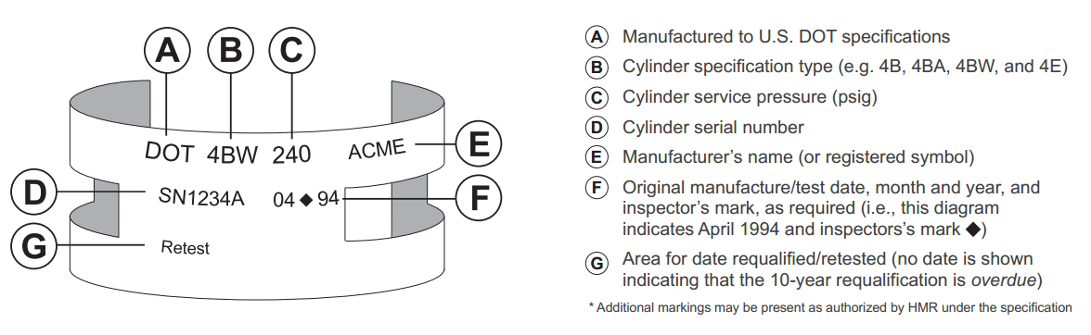

Requalification/Retesting (49 CFR § 180.205)

- The “requalification” date, also known as the “retest” date, is an important marking for fillers and/or consumers.
- Propane cylinders must be requalified or replaced every 5 or 10 years depending on the cylinder type, condition, and previous requalification method. (Ref. 49 CFR § 180.205(d) and 180.209(e).)
- The original manufacture/test date and any requalification/retest date(s) must be presented in a specific manner, reviewed, and determined to be within test prior to filling.

Visual Cylinder Inspection

In accordance with 49 CFR § 173.301(a)(2), cylinders must undergo a visual inspection prior to being filled. If any of the defects noted in items 1 through 4 below are present, the cylinder must not be filled and may only be repaired, requalified, or rebuilt by an authorized U.S. DOT facility (see authorized RIN and VIN holders below):
- Damage to the cylinder’s exterior including dents; bulges; cuts; or cracks on the cylinder’s surface, or to welds; and any evidence of physical abuse; fire; or heat damage.
- Detrimental rust, corrosion, or pitting on the cylinder, particularly on the bottom.
- Absence of/damage to a cylinder foot ring, cylinder neck ring (collar), or valve cover.
- A leaking or defective valve or leaking or defective pressure relief device.

A cylinder conforming to the Visual Inspection criteria also must be examined for the most recent repair, requalification, or rebuild date prior to filling. Cylinders that are overdue for requalification must NOT be refilled.

DOT 4-series propane cylinders must be requalified following their manufacture date every 5 or 10 years.

- If no requalification date is present, 10-years from the date of manufacture.
- If requalification was completed by the “Volumetric Expansion” method, as indicated by a valid RIN holder’s requalification mark, 10-years after that date.
- If requalification was completed by the “Proof-Pressure” method, as indicated by a valid RIN holder’s requalification mark followed by an “S”, 10-years after that date.
- If requalification was completed by the “External Visual” method, as indicated by a valid RIN or VIN holder’s requalification mark followed by an “E”, 5-years after that date.

Sample Requalification Marks (49 CFR § 180.213)

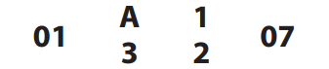
An approved RIN holder’s marking “A123” certifying a 10-year Volumetric Expansion test conducted in January 2007

The same RIN holder’s marking where “X” represents the symbol of the testing method used for requalification: “E”: 5-Year External Visual Method “S”: 10-Year Proof-Pressure Method

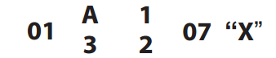

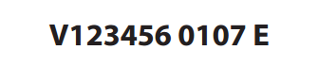
An External Visual marking for an approved VIN holder denoting the 5-Year External Visual method conducted in January 2007 (Ref. VIN Approval Letter)

NOTE: Requalification Marks may only be applied by valid U.S. DOT RIN (Requalified Identification Number) or VIN
(Visual Identification Number) holders!
Authorized RIN and VIN holders are listed: https://www.phmsa.dot.gov/hazmat/pressure-vessels-approvals/designated-approval-agencies-pdf
Failure to comply with (your company name), Propane Cylinder Qualifications policy will result in disciplinary action up to, or including, employment suspension or termination.

