Standard Operating Procedure - PROPANE CYLINDER QUALIFICATIONS
As an employee of <<COMPANYNAME>>, filling propane tanks may be part of your assigned duties, and you are required to adhere to all laws and regulations pertaining to filling propane cylinders. The following are the regulations and guidelines put into place by the U.S. Department of Transportation for qualification of a propane cylinder. At <<COMPANYNAME>>, SAFETY is everyone’s responsibility, which means it is YOUR responsibility.

Propane cylinders have identifying marks on the cylinder neck ring (collar) or cylinder shoulder, depending on the cylinder type. The diagram below depicts examples of several of the required markings:
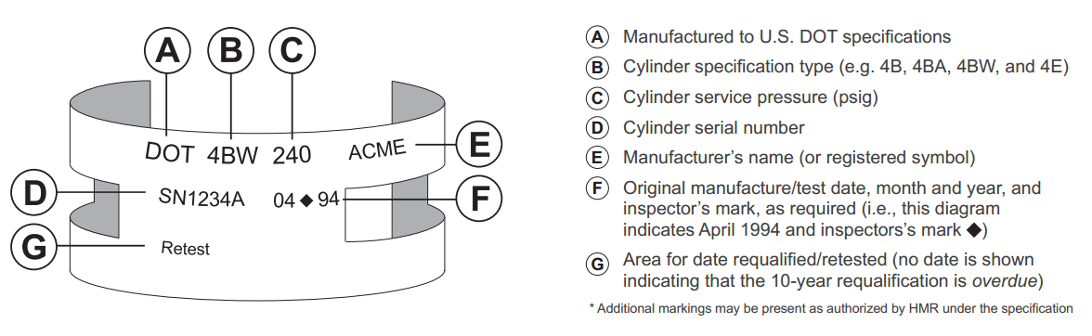

Requalification/Retesting (49 CFR § 180.205)
- The “requalification” date, also known as the “retest” date, is an important marking for fillers and/or consumers.
- Propane cylinders must be requalified or replaced every 5 or 10 years depending on the cylinder type, condition, and previous requalification method. (Ref. 49 CFR § 180.205(d) and 180.209(e).)
- The original manufacture/test dateand any requalification/retest date(s)must be presented in a specific manner, reviewed, and determined to be within test prior to filling.

Visual Cylinder Inspection
In accordance with 49 CFR § 173.301(a)(2), cylinders must undergo a visual inspection prior to being filled. If any of the defects noted in items 1 through 4 below are present, the cylinder must not be filled and may only be repaired, requalified, or rebuilt by an authorized U.S. DOT facility (see authorized RIN and VIN holders below):
- Damage to the cylinder’s exterior including dents; bulges; cuts; or cracks on the cylinder’s surface, or to welds; and any evidence of physical abuse; fire; or heat damage.
- Detrimental rust, corrosion, or pitting on the cylinder, particularly on the bottom.
- Absence of/damage to a cylinder foot ring, cylinder neck ring (collar), or valve cover.
- A leaking or defective valve, or leaking or defective pressure relief device.

A cylinder conforming to the Visual Inspection criteria also must be examined for the most recent repair,
requalification, or rebuild date prior to filling. Cylinders that are overdue for requalification must NOT be refilled.
DOT 4-series propane cylinders must be requalified following their manufacture date every 5 or 10 years.
- If no requalification date is present, 10-years from the date of manufacture.
- If requalification was completed by the “Volumetric Expansion” method, as indicated by a valid
RIN holder’s requalification mark, 10-years after that date.
- If requalification was completed by the “Proof-Pressure” method, as indicated by a valid RIN
holder’s requalification mark followed by an “S”, 10-years after that date.
- If requalification was completed by the “External Visual” method, as indicated by a valid RIN or
VIN holder’s requalification mark followed by an “E”, 5-years after that date.

Sample Requalification Marks (49 CFR § 180.213)

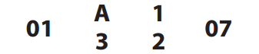
An approved RIN holder’s marking “A123” certifying a 10-year Volumetric Expansion test conducted in January 2007

The same RIN holder’s marking where “X” represents the symbol of the testing method used for requalification: “E”: 5-Year External Visual Method “S”: 10-Year Proof-Pressure Method

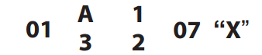

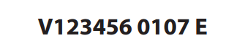
An External Visual marking for an approved VIN holder denoting the 5-Year External Visual method conducted in January 2007 (Ref. VIN Approval Letter)

NOTE: Requalification Marks may only be applied by valid U.S. DOT RIN (Requalified Identification Number) or VIN
(Visual Identification Number) holders!
Authorized RIN and VIN holders are listed: https://www.phmsa.dot.gov/hazmat/pressure-vessels-approvals/designated-approval-agencies-pdf
Failure to comply with ___________________ Propane Cylinder Qualifications policy will result in disciplinary action up to, or including, employment suspension or termination.

